Installation Instruction of Gurobi Student License

1. Go to Gurobi website (follow this link ([https://www.gurobi.com/downloads/request-an-](https://www.gurobi.com/downloads/request-an-evaluation-license/?utm_source=google&utm_medium=cpc&utm_campaign=2024%2Bna%2Bgoogleads%2Brequest%2Ban%2Bevaluation%2Blicense&campaignid=193283256&adgroupid=51266130904&creative=601650357807&keyword=gurobi&matchtype=e&_bn=g&gad_source=1&gclid=Cj0KCQjwurS3BhCGARIsADdUH51vftm9u9sWH5TR1Wr3calyYTsrR4m7yF2jsyNO9xpBeLB5KloMqjQaAtYBEALw_wcB) [evaluation-](https://www.gurobi.com/downloads/request-an-evaluation-license/?utm_source=google&utm_medium=cpc&utm_campaign=2024%2Bna%2Bgoogleads%2Brequest%2Ban%2Bevaluation%2Blicense&campaignid=193283256&adgroupid=51266130904&creative=601650357807&keyword=gurobi&matchtype=e&_bn=g&gad_source=1&gclid=Cj0KCQjwurS3BhCGARIsADdUH51vftm9u9sWH5TR1Wr3calyYTsrR4m7yF2jsyNO9xpBeLB5KloMqjQaAtYBEALw_wcB) [license/?utm_source=google&utm_medium=cpc&utm_campaign=2024+na+googleads+request+](https://www.gurobi.com/downloads/request-an-evaluation-license/?utm_source=google&utm_medium=cpc&utm_campaign=2024%2Bna%2Bgoogleads%2Brequest%2Ban%2Bevaluation%2Blicense&campaignid=193283256&adgroupid=51266130904&creative=601650357807&keyword=gurobi&matchtype=e&_bn=g&gad_source=1&gclid=Cj0KCQjwurS3BhCGARIsADdUH51vftm9u9sWH5TR1Wr3calyYTsrR4m7yF2jsyNO9xpBeLB5KloMqjQaAtYBEALw_wcB) [an+evaluation+license&campaignid=193283256&adgroupid=51266130904&creative=60165035](https://www.gurobi.com/downloads/request-an-evaluation-license/?utm_source=google&utm_medium=cpc&utm_campaign=2024%2Bna%2Bgoogleads%2Brequest%2Ban%2Bevaluation%2Blicense&campaignid=193283256&adgroupid=51266130904&creative=601650357807&keyword=gurobi&matchtype=e&_bn=g&gad_source=1&gclid=Cj0KCQjwurS3BhCGARIsADdUH51vftm9u9sWH5TR1Wr3calyYTsrR4m7yF2jsyNO9xpBeLB5KloMqjQaAtYBEALw_wcB) [7807&keyword=gurobi&matchtype=e&_bn=g&gad_source=1&gclid=Cj0KCQjwurS3BhCGARI](https://www.gurobi.com/downloads/request-an-evaluation-license/?utm_source=google&utm_medium=cpc&utm_campaign=2024%2Bna%2Bgoogleads%2Brequest%2Ban%2Bevaluation%2Blicense&campaignid=193283256&adgroupid=51266130904&creative=601650357807&keyword=gurobi&matchtype=e&_bn=g&gad_source=1&gclid=Cj0KCQjwurS3BhCGARIsADdUH51vftm9u9sWH5TR1Wr3calyYTsrR4m7yF2jsyNO9xpBeLB5KloMqjQaAtYBEALw_wcB) [sADdUH51vftm9u9sWH5TR1Wr3calyYTsrR4m7yF2jsyNO9xpBeLB5KloMqjQaAtYBEALw_](https://www.gurobi.com/downloads/request-an-evaluation-license/?utm_source=google&utm_medium=cpc&utm_campaign=2024%2Bna%2Bgoogleads%2Brequest%2Ban%2Bevaluation%2Blicense&campaignid=193283256&adgroupid=51266130904&creative=601650357807&keyword=gurobi&matchtype=e&_bn=g&gad_source=1&gclid=Cj0KCQjwurS3BhCGARIsADdUH51vftm9u9sWH5TR1Wr3calyYTsrR4m7yF2jsyNO9xpBeLB5KloMqjQaAtYBEALw_wcB) [wcB](https://www.gurobi.com/downloads/request-an-evaluation-license/?utm_source=google&utm_medium=cpc&utm_campaign=2024%2Bna%2Bgoogleads%2Brequest%2Ban%2Bevaluation%2Blicense&campaignid=193283256&adgroupid=51266130904&creative=601650357807&keyword=gurobi&matchtype=e&_bn=g&gad_source=1&gclid=Cj0KCQjwurS3BhCGARIsADdUH51vftm9u9sWH5TR1Wr3calyYTsrR4m7yF2jsyNO9xpBeLB5KloMqjQaAtYBEALw_wcB))



Figure : Home page of Gurobi Optimization website.

1. Go to download and licenses.

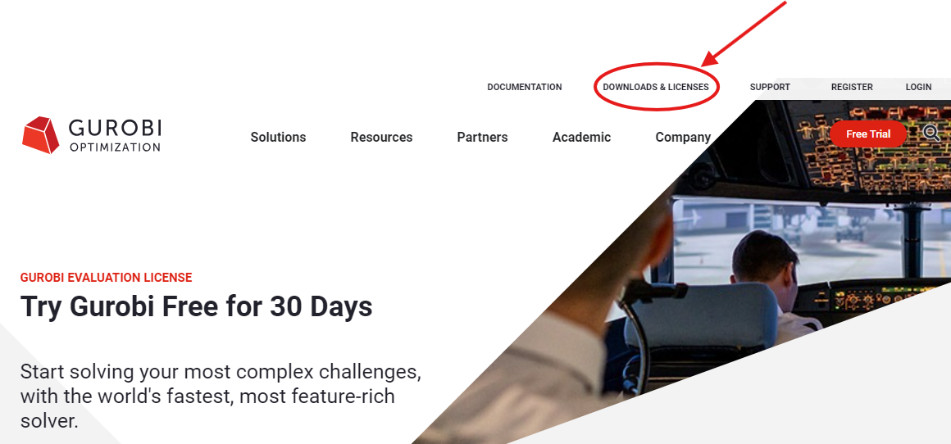

and download the latest version for your operating systems, Windows or Mac and set it up (follow this link [https://www.gurobi.com/downloads/gurobi-](https://www.gurobi.com/downloads/gurobi-software/) [software/](https://www.gurobi.com/downloads/gurobi-software/))

1. Go to Gurobi website again and click on Academic and click on Gurobi for Academics (follow this link <https://www.gurobi.com/academia/academic-program-and-licenses/> ).
2. Click on Academic Named-User License saying **Learn More** (follow this link <https://www.gurobi.com/features/academic-named-user-license/>)
3. Click on Register for a free Gurobi account as an academic and log in (follow this link <https://portal.gurobi.com/iam/register/>). Open an account with your Ohio university email and request a license for one year.
4. Go to licenses. It will look like the pic shown in Figure 1.

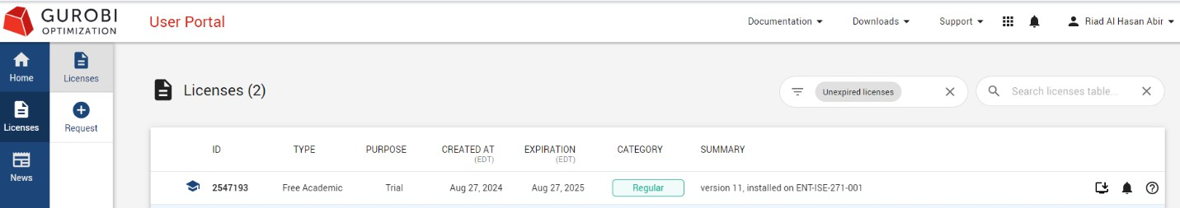

*Figure 1: Licenses.*

1. Click on the license. It will show a window as it is shown in Figure 2.

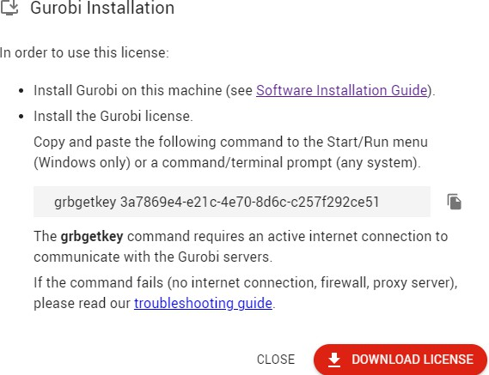

*Figure 2: License Key*

1. Copy the license key to the command prompt in your computer as shown in Figure 3 and hit run. That’s it you are good to go.

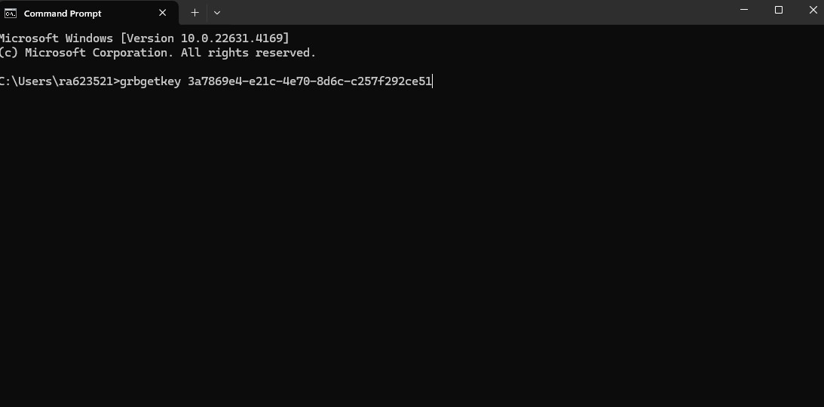

*Figure 3: Run license in command prompt.*